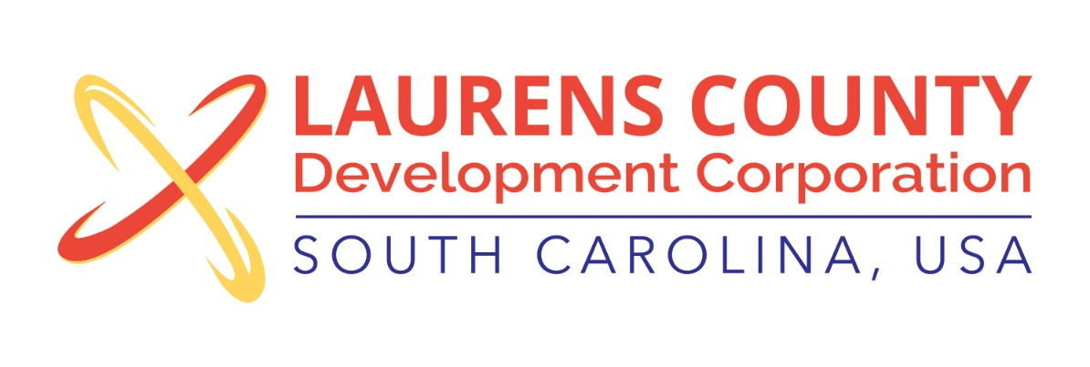
Board Meeting
Tuesday, November 21, 2017
12:00 PM
Laurens County Chamber of Commerce

MEETING AGENDA

- Welcome / Call to Order / Invocation – Jeff Field
- Approval of Agenda – Jeff Field
- Approval of 9/19/17 Minutes – Jeff Field
- Review of September & October 2017 Financials – Lynn Finley

Business/Reports

- Executive Director’s Report – Jonathan Coleman
- SC PEBA Benefits update – Jonathan Coleman
- 2018 Budget Approval – John Young, Treasurer
- Spec Building Agreement with LCPW – Jonathan Coleman
- Annual Meeting – Jonathan Coleman
- Other Reports

Executive Session (if needed)

Adjourn

