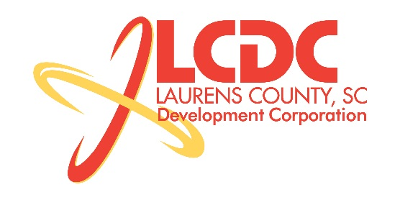
Board Meeting
Tuesday, November 17, 2015
2:30 PM
Piedmont Technical College Higher Education Center – Rm 331

MEETING AGENDA

- Welcome / Call to Order / Invocation – Stan Bryson
- Approval of Agenda – Stan Bryson
- Approval of 9/15/15 Minutes – Stan Bryson
- Review of September/October Financials & Investor Update – Lynn Finley

Business/Reports

- Existing Industry/Workforce Development – Jonathan Coleman
- Retail Strategies Update – Joe Strauss, Retail Strategies
- New Prospect Activity – Marvin Moss
- CEDC Update – Frank Stovall
- Main Street Laurens Update – John Young
- Upstate Alliance Update – Lauren Scoggins
- Organizational Update – Jonathan Coleman
- Finance Committee Update – Frank Stovall
  - 2016 Budget Approval
- Possible Bylaw Modification – Jonathan Coleman

Executive Session (if needed)

Adjourn

