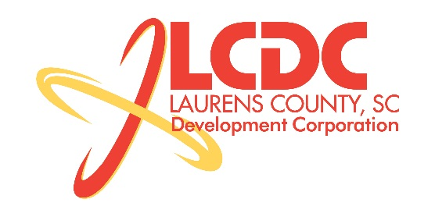
Board Meeting
Tuesday, March 17, 2015
12:00 PM
Laurens County Chamber of Commerce

MEETING AGENDA

- Welcome / Call to Order / Invocation – Stan Bryson
- Approval of Agenda – Stan Bryson
- Approval of 1/20/15 Minutes – Stan Bryson
- Review of January/February Financials & Investor Update – Lynn Finley

Business/Reports

- Existing Industry/Retail Update – Jon Coleman
- Economic Development Update – Marvin Moss
- CEDC Update – Collie Lehn
- Laurens ED Update – John Young
- Upstate Alliance Update – John Lummus
- Approval of Revised Budget – Frank Stovall
- Review SCDOC County Assessment – Marvin Moss

Executive Session (if needed)

Adjourn

