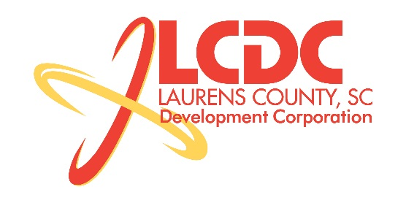
Board Meeting
Tuesday, May 20, 2014
12:00 PM
Laurens County Chamber of Commerce

MEETING AGENDA

- Welcome / Call to Order / Invocation – Jim Coleman
- Approval of Agenda – Jim Coleman
- Approval of 03/18/14 Minutes – Jim Coleman
- Review of Mar/Apr Financials & Investor Update – Marvin Moss

Business/Reports

- Existing Industry/Retail Update – Jon Coleman
- Economic Development Update – Marvin Moss
- CEDC Update – Collie Lehn
- Laurens First Update – John Young
- Upstate Alliance Update – TBD
- Site Selection Update – Marvin Moss
- Other business

Executive Session

Economic Development matter

Adjourn

