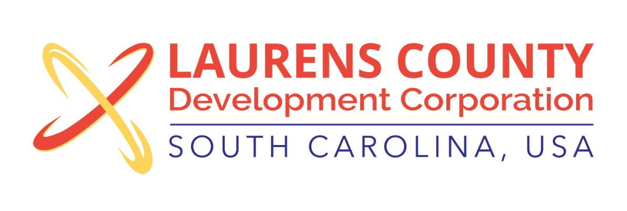
Board Meeting
Tuesday, July 17, 2018
12:00 PM
Laurens County Chamber of Commerce

MEETING AGENDA

- Welcome / Call to Order / Invocation – Jeff Field
- Approval of Agenda – Jeff Field
- Approval of 5/15/18 Minutes – Jeff Field
- Review of May & June 2018 Financials – Lynn Finley

Business/Reports

- 2017 Annual Audit Report – Matt Phillips, McKinley Cooper
- Prospect Activity – Jonathan Coleman
- New Marketing Materials & Update – Whitney Robertson
- Product Development Update – Jonathan Coleman
- Industry Showcase – Lynn Finley
- September Board Meeting – Jeff Field

Adjourn

