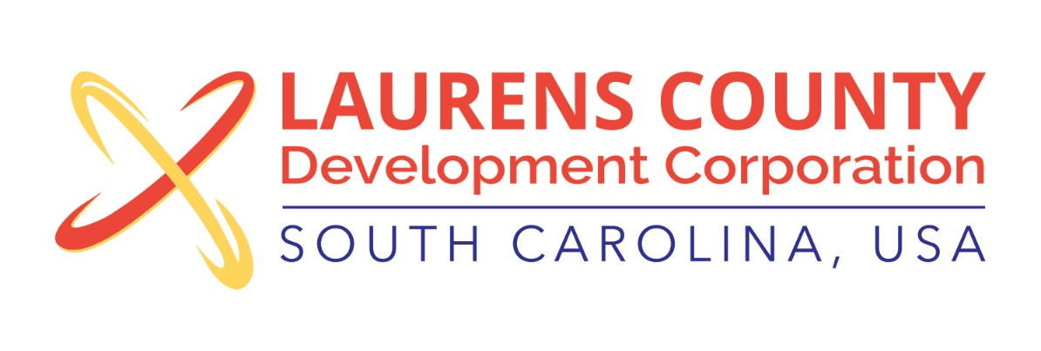
Board Meeting
Tuesday, September 20, 2016
12:00 PM
Laurens County Chamber of Commerce

MEETING AGENDA

- Welcome / Call to Order / Invocation – Stan Bryson
- Approval of Agenda – Stan Bryson
- Approval of 7/19/16 Minutes – Stan Bryson
- Review of July & August Financials – Lynn Finley

Business/Reports

- Executive Director’s Report – Jonathan Coleman
- Industry Tour – Jonathan Coleman
- OIP Reinvest Fund (Powers South Recertification) Resolution - Stan Bryson
- Appointment of Nominating Committee – Stan Bryson
- November Board Meeting Date 11.8.16 – Stan Bryson
- Other Reports

Executive Session (if needed)

Adjourn

